# Lab 3 - Data Transformation and Querying in Amazon Redshift

1. Perform an ELT operation with materialized views and stored procedures.
2. Use Amazon Redshift scheduled queries.
3. Query data directly from the source using Amazon Redshift data sharing.

* **ETL (Extract, Transform, Load): First, we extract the data, transform it to a needed format, and then load it into Redshift.**

**to retain only the parts of the raw data that you need.**

* **ELT (Extract, Load, Transform): First, we extract the data, load it into Redshift, and then transform it using Redshift's capabilities.**

In this lab, you load stock market data (stored in Amazon S3) into Amazon Redshift. You first query the data as is. Then, you create a materialized view to transform the data (to better suit your needs) and query that view. Finally, you create a scheduled task to query the materialized view at a set interval, and you learn how to retrieve the results of a scheduled query.

Pre-created

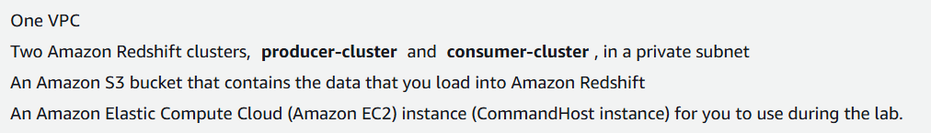

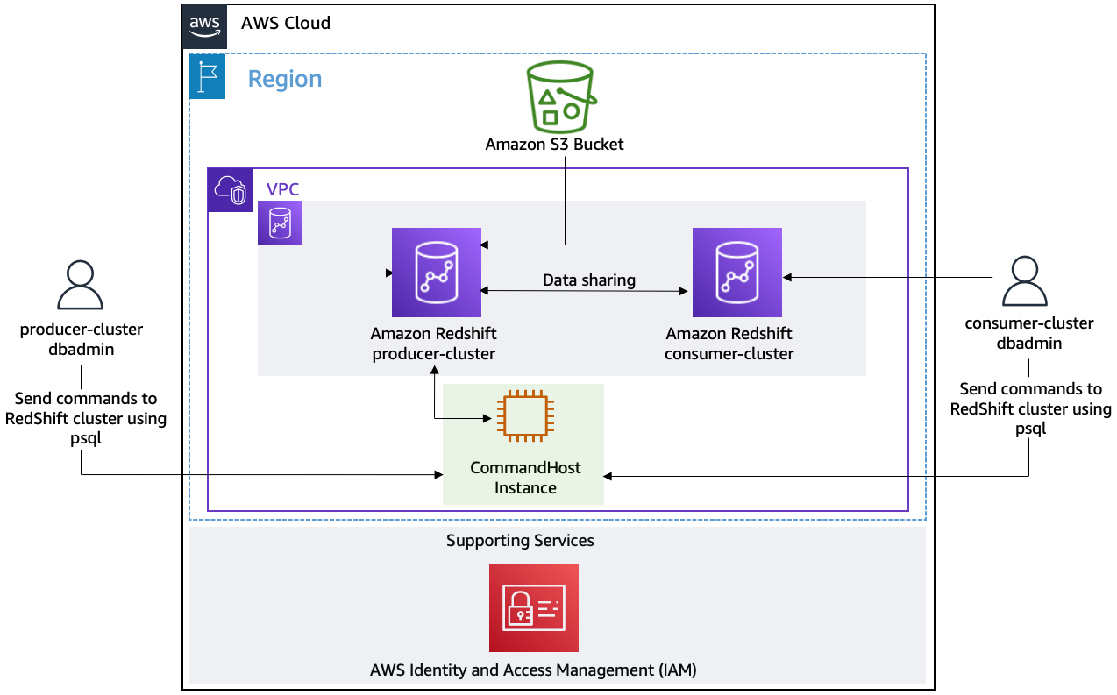

Producer-Cluster: This is where the data is initially loaded and possibly transformed.

Consumer-Cluster: This is where the data is shared and used for analysis.

1. **Load Data into Amazon Redshift**: The producer-cluster dbadmin loads data from Amazon S3 into the producer-cluster.

2. **Data Sharing**: The producer-cluster shares its data with the consumer-cluster without duplicating it.

3. **Analyze Data in Consumer-Cluster**: The consumer-cluster dbadmin queries and analyzes the shared data.

4. **CommandHost Instance**: Manages and sends commands to both the producer and consumer clusters.

**Task 1: Explore the lab environment**

1.1 open s3 location

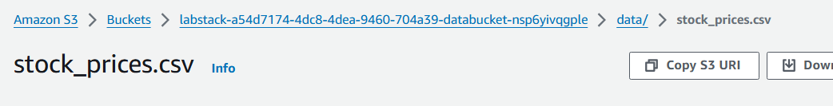

1.2 in RS

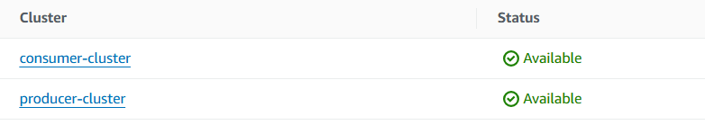

1.3 copy both Endpoints

**Task 2: Create an external table**

2.0 open URL to CLI

2.1 connect to producer cluster

cd ~

export PGPASSWORD='<INSERT_PASSWORD>'

psql -U dbadmin -h '<INSERT_REDSHIFT_CLUSTER_ENDPOINT>' -d producer_stocks -p 5439



2.2 in prod, create schema and table

CREATE EXTERNAL SCHEMA spectrum

FROM DATA CATALOG

DATABASE spectrumdb

IAM_ROLE 'INSERT_REDSHIFT_ROLE'

CREATE EXTERNAL DATABASE IF NOT EXISTS;

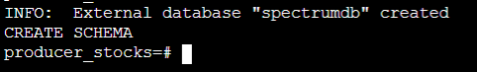

2.3 create external table

DROP TABLE IF EXISTS spectrum.stocksummary;

CREATE EXTERNAL TABLE spectrum.stocksummary(

Trade_Date VARCHAR(15),

Ticker VARCHAR(5),

High DECIMAL(8,2),

Low DECIMAL(8,2),

Open_value DECIMAL(8,2),

Close DECIMAL(8,2),

Volume DECIMAL(15),

Adj_Close DECIMAL(8,2)

)

ROW FORMAT DELIMITED

FIELDS TERMINATED BY ','

STORED AS TEXTFILE

LOCATION 's3://INSERT_DATA_BUCKET/data/';



2.4 works

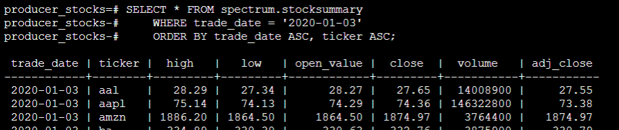



**Task 3: Create and query a materialized view - T from ETL**

A materialized view (MV) is a database object that contains the results of a query, stored as a physical table, allowing for faster access to precomputed data compared to executing the query each time it is requested.

3.1

DROP MATERIALIZED VIEW IF EXISTS stocks_mv;

CREATE MATERIALIZED VIEW stocks_mv AS

SELECT trade_date, ticker, volume FROM spectrum.stocksummary;

it only shows the selected columns

Like here, we create MV such that a query which only returns these three columns of the table

3.2 query

SELECT * FROM stocks_mv

WHERE trade_date = '2020-01-03'

ORDER BY trade_date ASC, ticker ASC;

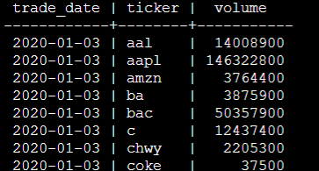



**Task 4: Use Amazon Redshift data sharing for faster data access between clusters**

With Amazon Redshift data sharing, you can grant access directly to specific data and objects in one Redshift cluster to entities in another cluster.

It is helpful in case you (consumer DB admin) want to see live data from producer DB, and dont’t have to wait for complete copy of data from prod to cons.

4.1 copy namespace values

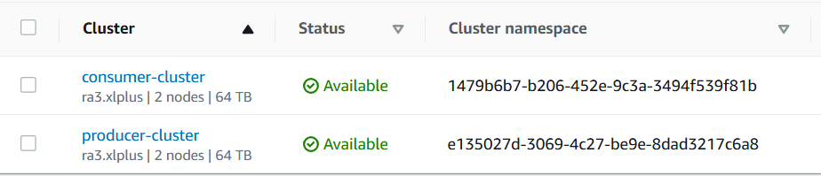

4.2 in cli

CREATE DATASHARE stocks_share;



4.3 add schema and MV to data share

ALTER DATASHARE stocks_share ADD SCHEMA public;

ALTER DATASHARE stocks_share ADD TABLE public.stocks_mv;

4.4 grant consumer access to producer via data share

GRANT USAGE ON DATASHARE stocks_share TO NAMESPACE 'INSERT_CONSUMER_NAMESPACE_ID';



4.5 verify

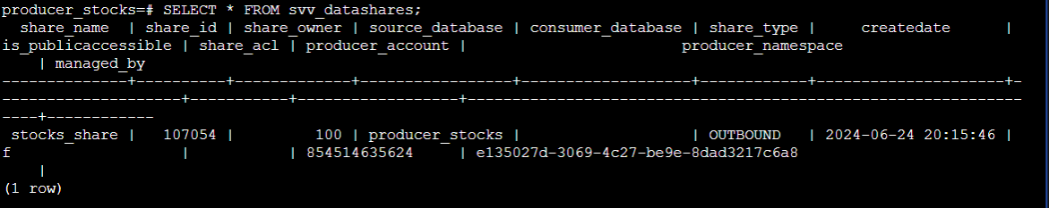

Source - producer_stocks

Share type - OUTBOUND (prod -> cons)

4.6

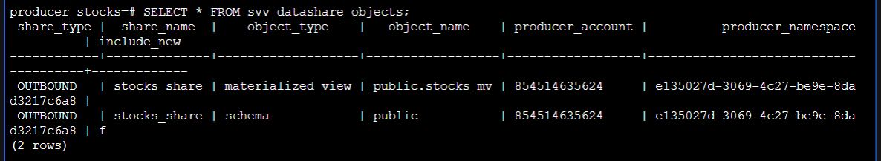

2 things outbound - schema and MV

4.7 verify from consumer side

Connect to consumer cluster using endpoint



4.8 view datashare

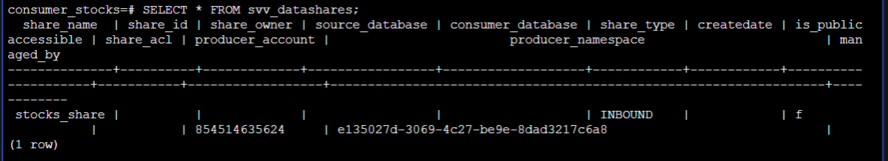

INBOUND

4.9 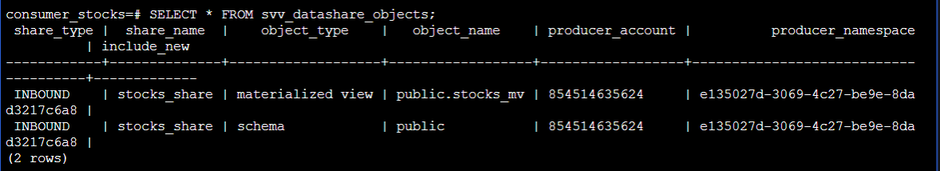

4.10 query in consumer

CREATE DATABASE stock_summary FROM DATASHARE stocks_share of NAMESPACE 'INSERT_PRODUCER_NAMESPACE_ID';

4.11 now, get data from MV, which was shared from producer to consumer

SELECT * FROM stock_summary.public.stocks_mv

WHERE trade_date = '2020-01-03'

ORDER BY trade_date ASC, ticker ASC;

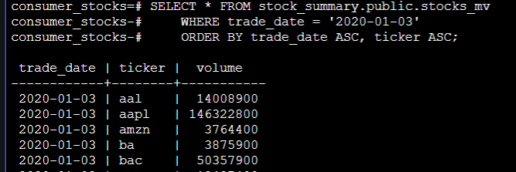

To revoke data share, go to producer

REVOKE USAGE ON DATASHARE stocks_share FROM NAMESPACE 'INSERT_CONSUMER_NAMESPACE_ID';